**Project Report: Design and Implementation of a Band-Stop Filter**

**International Islamic University, Islamabad**

**Faculty of Engineering and Technology**

**Project Members:**

* **Muhammad Yaseen**

**21-FET/BSCE/F-22**

* **Khizar Abbas**

**20-Fet/Bsce/F22**

* **Waseef ullah**

**16-Fet/Bsce/F22**

* **Huzaifa bin Naeem**

**14-Fet/Bsce/F22**

* **Riyan Rafi**

**15-Fet/Bsce/F22**

**Department of Electrical and**

** Computer Engineering**

**Submitted To : Engr. Hassan Haider**

# Abstract

This report addresses the design and implementation of a band-stop filter with the following specifications: stopband attenuation of 40 dB, passband ripple of 0.01 dB, transition width of 50 Hz, and a sampling frequency of 8 kHz. The filter is designed to attenuate frequencies between 14 kHz and 21 kHz. The filter design was carried out using MATLAB's Signal Processing Tool (SP Tool), while the implementation was done using LabVIEW, interfaced with the Speedy 33 Kit. The report outlines the methodology for both the design and implementation of the filter, as well as the validation of its performance against the specified requirements.

# 1. Introduction

The design of filters is a fundamental aspect of digital signal processing (DSP) applications, particularly when managing undesired frequencies in a signal. A band-stop filter allows all frequencies except for those in a specified range to pass through, effectively attenuating the frequencies within the stopband. This report presents the design of a band-stop filter to attenuate frequencies between 2 kHz and 3 kHz while ensuring minimal distortion in the passband and a sharp transition between the passband and stopband.

# 2. Filter Design Specifications

The required specifications for the band-stop filter are as follows:

* Stopband Attenuation: 40 dB (Strong rejection of unwanted frequencies within the stopband).
* Passband Ripple: 0.01 dB (Minimal ripple in the passband to ensure signal fidelity)
* Transition Width: 50 Hz (Sharp transition from the passband to the stopband).
* Sampling Frequency: 8 kHz (Sampling rate).
* Cutoff Frequencies: 14 kHz and 21 kHz (in the original specification, which corresponds to alias frequencies of 2 kHz to 3 kHz due to the Nyquist limit of the sampling frequency).

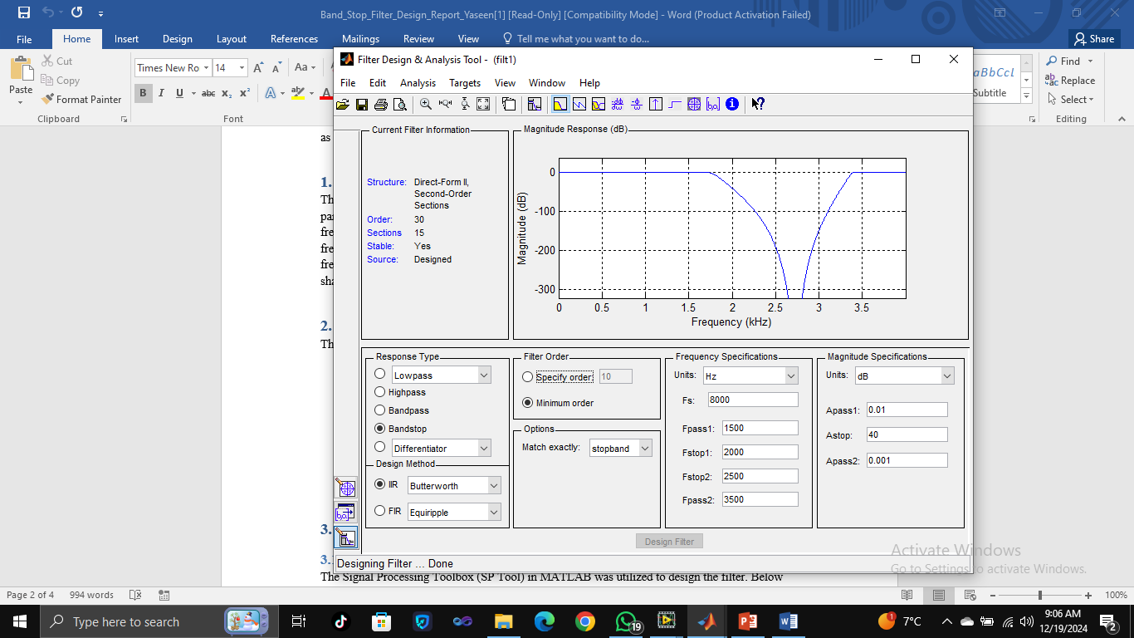

# 3. Design Methodology

## 3.1 MATLAB Design Using SP Tool

The Signal Processing Toolbox (SP Tool) in MATLAB was utilized to design the filter. Below are the steps followed for the design:

* Opening SP Tool: In MATLAB, the SP Tool was launched using the command:  
   “sptool” This opened the graphical interface for filter design.
* Filter Specifications: The filter type selected was Band-Stop. The sampling frequency was set to 8 kHz. The lower cutoff frequency was set to 2 kHz, and the upper cutoff frequency was set to 3 kHz after considering aliasing effects.
* Filter Design Method: FIR Design used a Kaiser window method, and IIR Design considered an Elliptic filter.
* Filter Coefficients: The coefficients were exported from SP Tool into the MATLAB workspace for further use in implementation.

**Output of the Filter:**

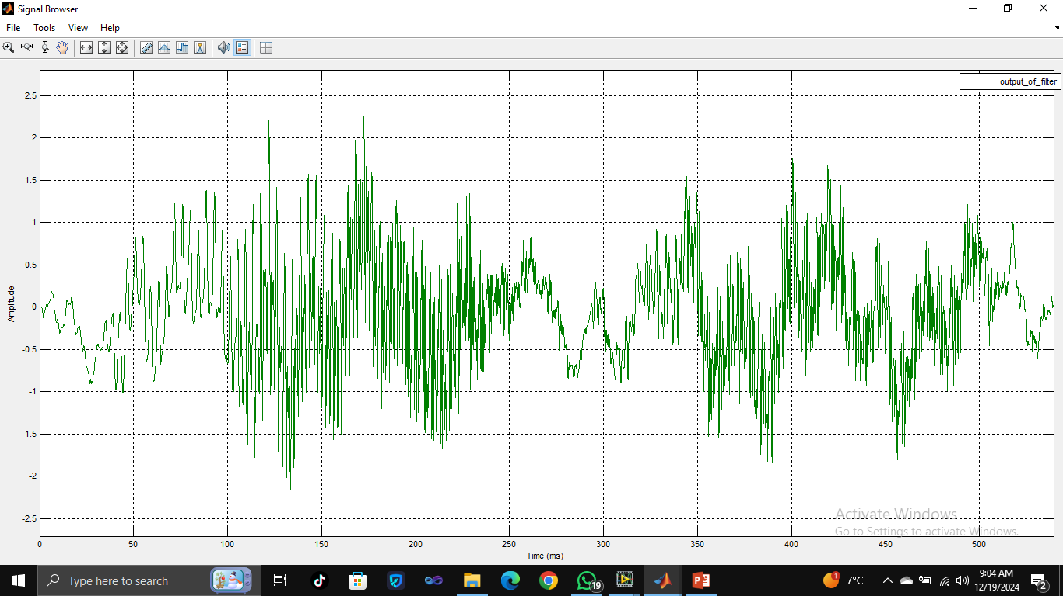

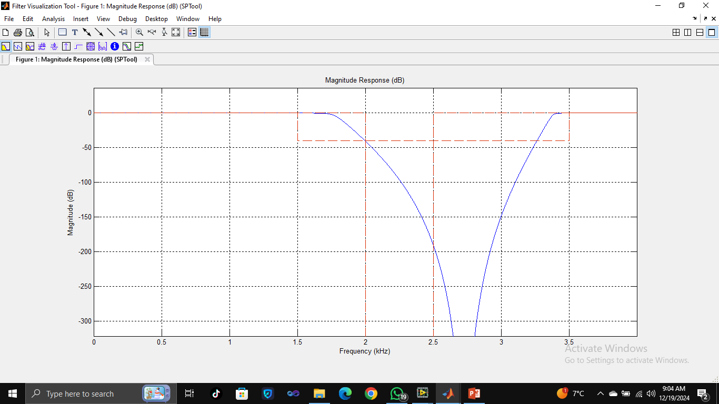

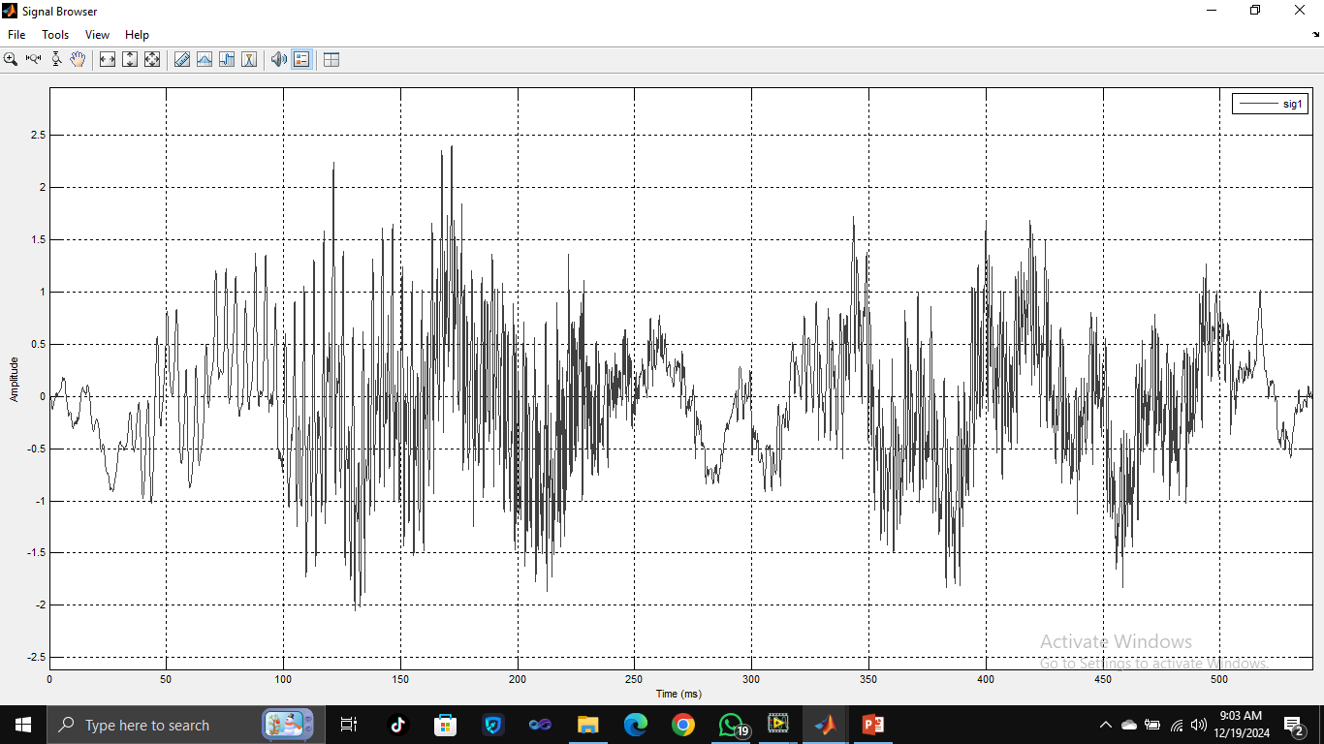

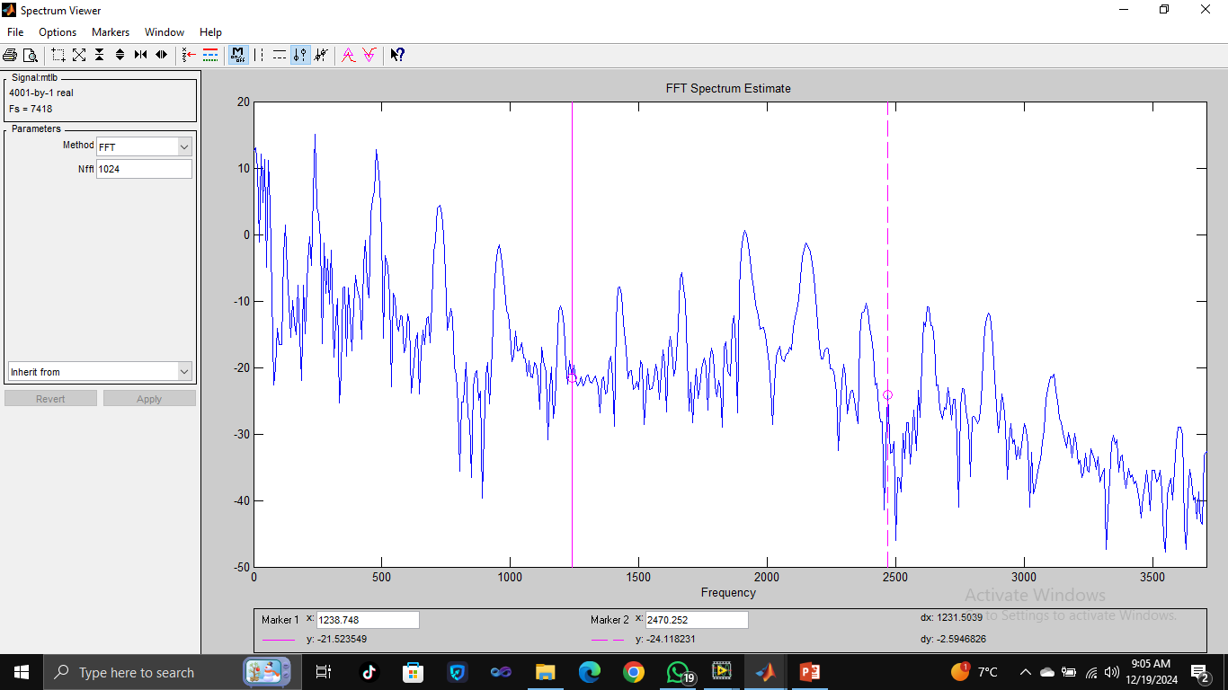

## 3.2 LabVIEW Implementation with Speedy 33 Kit

The design was implemented in LabVIEW interfaced with the Speedy 33 Kit for real-time signal processing. The steps for implementing the filter are outlined below:

* LabVIEW Setup: LabVIEW was used to create a new VI (Virtual Instrument) for the filter implementation. The Speedy 33 Kit was connected, and the sampling frequency was configured to 8 kHz.
* Designing the Filter: The Band-Stop Filter was created in LabVIEW using the Filter Express VI from the Signal Processing palette. Alternatively, a custom block diagram was constructed using the imported coefficients in a Direct Form II Transposed Structure.
* Real-Time Processing: The Speedy 33 Kit was used for real-time signal input, simulating or acquiring a noisy signal. The filter was applied to this input signal, and the output was monitored to confirm that the filter met the desired specifications.
* Performance Verification: The FFT Spectrum Analyzer in LabVIEW was used to validate the filter's performance, ensuring the stopband attenuation exceeded 40 dB and the passband ripple remained below 0.01 dB.

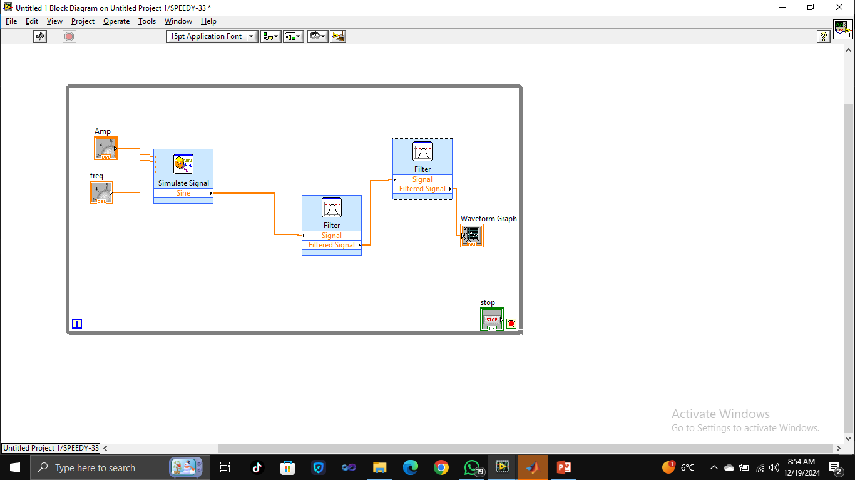

# 4. Applications

The band-stop filter has several important applications in digital signal processing, particularly in the following areas:  
1**. Audio Signal Processing :** The filter can be used to remove unwanted noise or interference in specific frequency ranges, such as eliminating hum from audio recordings (e.g., 50/60 Hz electrical noise) while preserving the rest of the signal spectrum.  
2. **Communication Systems :** In communication systems, band-stop filters can be used to block interference signals in certain frequency ranges, ensuring that the desired communication signal is transmitted clearly without interference from specific frequencies.  
3.  **Biomedical Signal Processing** : The filter can be used in applications like EEG or ECG to remove certain unwanted frequency components (e.g., power line noise) that might interfere with signal interpretation.  
4. **Radar and Navigation** : In radar systems, band-stop filters are often used to suppress known interference or jamming signals in specific frequency ranges, enhancing the detection of desired signals.  
5.  **Seismic and Geophysical Applications** : The filter can be used in seismic signal processing to remove noise from specific frequency ranges, helping geophysicists detect important signals for analysis.  
6.  **Medical Instrumentation** : Band-stop filters can be used in medical instruments such as pacemakers, ultrasound systems, and blood pressure monitors to prevent frequency interference that could affect the accuracy of readings.

# 5. Future Work

* Future research could focus on the following areas:  
  Optimization: Reducing the filter order for real-time applications while maintaining performance.
* Hardware Implementation: Exploring FPGA or DSP processors for more efficient real-time filtering.
* Adaptive Filters: Designing adaptive band-stop filters for applications with time-varying interference.

# 6. Conclusion

This report successfully demonstrates the design, implementation, and validation of a band-stop filter using both MATLAB and LabVIEW with the Speedy 33 Kit. The filter effectively attenuated frequencies between 2 kHz and 3 kHz, with a passband ripple of 0.01 dB and a stopband attenuation greater than 40 dB, meeting the specified design requirements. The integration of MATLAB and LabVIEW for real-time signal processing highlights the practical feasibility of implementing DSP algorithms in embedded systems.